**RIPHAH INTERNATIONAL UNIVERSITY, ISLAMABAD**



**Lab # 2**

**Bachelor of Computer Science – 6th Semester**

**Subject: Operating System**

**Submitted to: Ms. Kausar**

**Submitted by: Hafsa Maqsood-40880**

**Date of Submission: 02- Sep -2024**

**QUESTION NO#1**

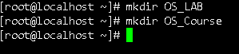

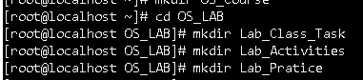





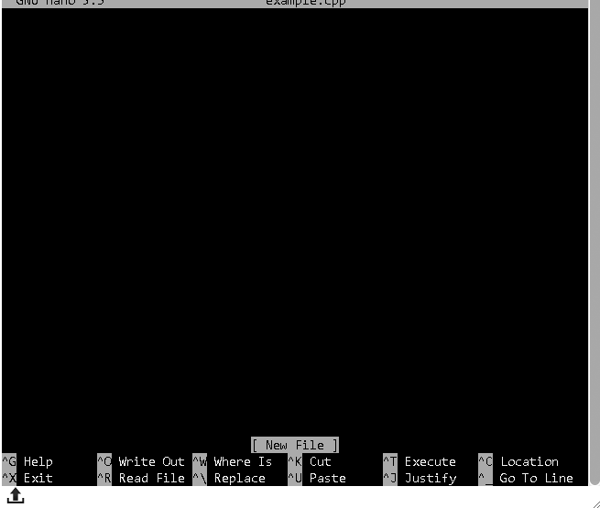

**QUESTION NO#2**

Absolute Path

An absolute path is a complete path that starts from the root directory (/) and specifies the entire path to a file or directory. It includes all the directories from the root to the desired location.

Example

: 

Relative Path

A relative path is a partial path that starts from the current working directory. It does not start from the root directory.

Example:



If we are in the lab_practice directory we go the parent directory os_lab then we access the lab_Activities directory relative path.

**QUESTION NO#3**

**Press the Power Button:** This sends a signal to turn on the computer.

**power supply** :sends a signal to the power supply, which then provides electrical power to the motherboard and other component

**Self-Test (POST):** The computer quickly checks whether essential parts like the CPU and RAM work.

**BIOS:** The BIOS (Basic Input/Output System) initializes the hardware and prepares the system to load the operating system.

**User Interface**: The OS presents the login screen or desktop.

Modern storage devices like SSDs (Solid-State Drives) provide rapid data access, speeding up the boot process.